**Executive Summary:**   
The ATR system was created for the purpose of digitizing the sign in system for the athletic training room. Throughout this process we created documentation to outline the project and create a framework that was used as guidance for the creation process. This document includes all of the relevant documents that were created for this purpose. Within the document you will find: an abstract that details the core of the project, questions we asked the athletic trainers, a database schema showcasing our database layout, documentation of the problems we had throughout the project, and future goals of the project. The documentation will detail how our web application interacts with our database. Data is dynamically transferred between both while using the application. It is though these documents that we hope we’ve enhanced the athletic experience at Loras College.

**Abstract:**

The objective of this project is to create a web interface application to enhance the injury reporting system at Loras College. With this system, an athlete will be able to clearly and efficiently report his injuries after the completion of two short forms. Whereas before, you could sloppily write your name and injury on the paper log in the Athletic Training room. Another advantage of this system is that the Athletic Trainers will be able to analyze the injury reports more effectively than before. We implemented a series of queries on the Athletic Training side of the system that allows the Athletic Trainers to view injury reports, based on certain characteristics, all with the click of a button. This is much easier than sorting through the stack of unorganized binders in the Athletic Training Room to try and find information about an injury.

**Questions:**  
To get our project up and running we asked the athletic trainers some question about requirements for the database.  
  
  
What type of pages need to be on the website?  
On those pages what information do you need to be able to see?  
Does the site need to be mobile friendly?  
What types of things are a must for the web application?  
Which injuries need to be on a drop down?  
Should injury choice include left or right or should that be in the description part?  
  
**Results:**   
The athletic trainers provided great feedback and we came to following conclusions on requirements for the system. First the sign up system must be quick and pain free as there is no current sign up system. With a the current paper system there is no need to create usernames so we aimed to create a streamline system that would take less than ten seconds. Next, the login in and documentation of injuries must be quick so no lines form behind people checking in. The current system has lots of binders laid out on a desk and athletes must try to find the right binder to sign in on. Our system must eliminate any confusion on where to sign in at and if the sign in is in the right spot. The system must include all type of body injuries and if an injury is not in the system a way to request it to be added. Finally the trainers must have a hub where they can interact with the data in useful ways such as athlete injury look up and break down of all injuries.

**Login/Injury Report Sequence Diagram:** This diagram shows how the app interacts with the database when the student athlete enters an injury report.

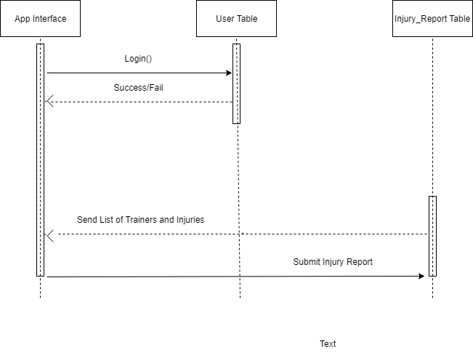

**Activity Diagrams:** The student athlete activity diagram shows the steps a student athlete takes submit an injury report. It also shows how the website interacts in the process. The athletic trainer activity diagram shows the steps an athletic trainer takes to view the reports. It also shows how the website interacts in the process.

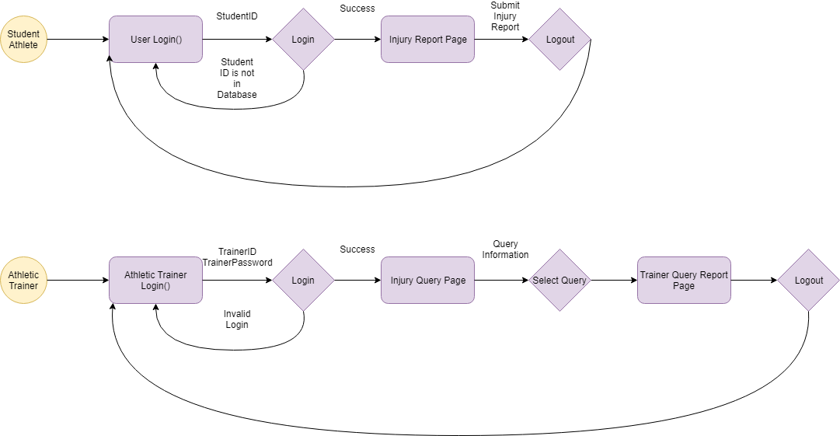

**Database Table Schema:** This schema shows the layout of the database. It shows all the tables and how the tables are connected with each other.

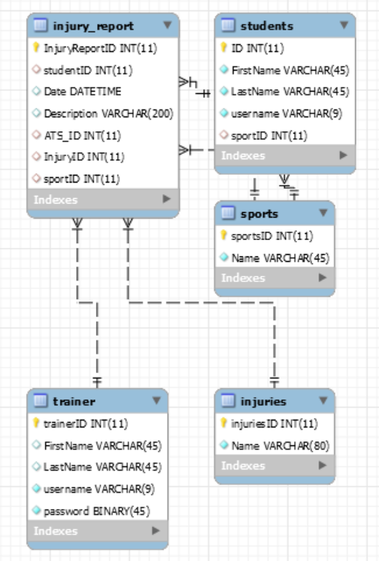

**Interactions:**

Application → MySql

* Send username
* Send new user sign up info
* Send a new injury report

MySql → Application

* Send if username already exists
* Send back if account got created

**Context Level Diagram:** The context level diagram shows what interactions people have with the application and how the application interacts back to the people. It also shows how the application interacts with the database.

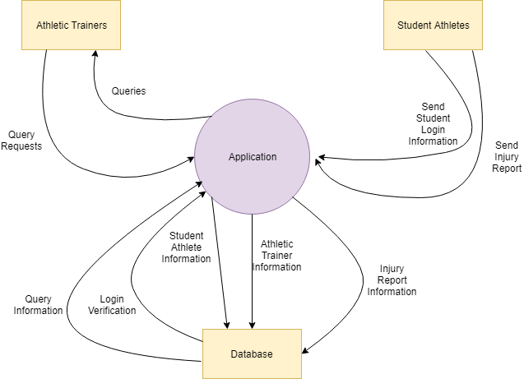

**Athletic Trainers Diagram 0:** This diagram is another way to show the steps it takes the Athletic Trainers to view a injury report query.

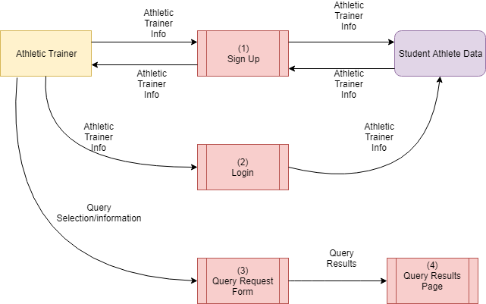

**Student Athlete Diagram 0:**This diagram is another way to show the steps it takes the Student Athletes to submit an injury report.

